- Presentation

The MSM (MulitSystMetrolog) software was developed so as to manage measurement systems allowing :
- machines positioning,
- structural control and survey.
Its principal functions are the following :
- Management and acquisition of measurement data from the RIA 8µP rack to which FOGALE Nanotech instruments or other are connected.
- Installation visualization
- Measurement data display
- Simultaneous specific data processes
- Measurement data saving
- Management of RIA 8µP racks network
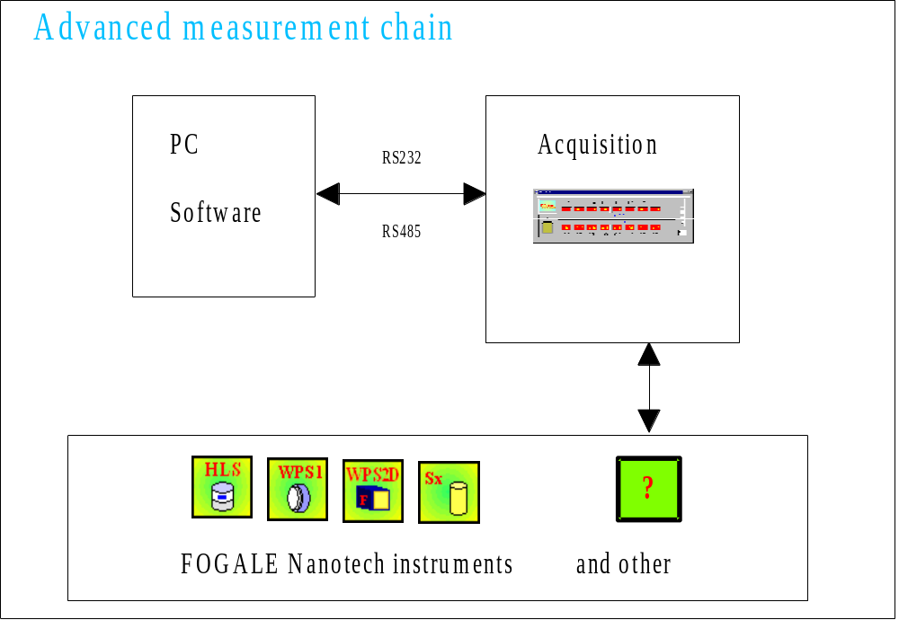

The MultiSystMetrolog software was developed in C / C++ in Visual 5.0 and in the Windows NT4.0. environment. Its automatic Setup spares the user complex manipulations on the operating system.

- Installation

The present section describes the installation procedure.

The MSM files are originally compressed and are automatically uncompressed during installation. The Setup program has to be runned before installing and running MSM.

2.1. Material features

2.1.1. Minimum required material
- Pentium 166
- 32 Mo
- Display adaptator, resolution SVGA 1024x768, 256 colors
- Hard disk unit, CD ROM player
- 200 Mo minimum disk free space

2.1.2. Advised configuration
- Microprocessor Pentium III 500 or better
- 256 Mo
- 400 Mo disk free space

2.1.3. Required environment
Windows NT 4.0 Pack 6a or advanced version
Windows 2000 Pro or advanced version

2.2. Installation of MultiSystMetrolog

Remark : before installation of a new version, please uninstall former version (Cf. &2.3).

2.2.1. Lauching the Setup program

- Open the « Administrator » session of Windows NT,
- Insert CD in PC CD ROM player,
- Launch the setup.exe program located on the CDROM in the following directory :

Disk Images\Disk1

2.2.2. Welcome dialog

The welcome dialog recommends to quit all applications in Windows before running the Setup program.
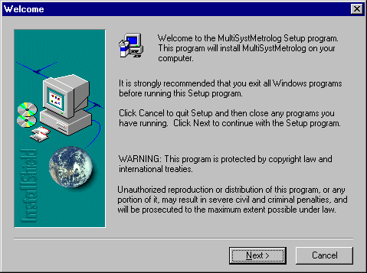

Click on the Next button if no other application is running, otherwise quit the Setup program by clicking on cancel so as to quit all active files and applications.

2.2.3. Acceptation of the enduser licence contract

This dialog describes the licence contract for MSM. If you do not accept conditions (No), the Setup stops.
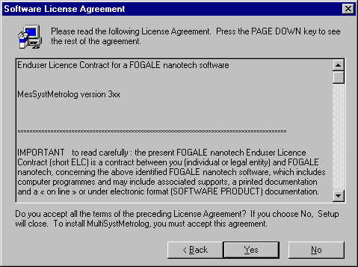Click on the Back button to come back to the former dialog.

Click on Yes to accept the licence contract conditions and go to the next dialog.

2.2.4. General information

This dialog gives general information about the software.

Click on Cancel to cancel the software Setup program.
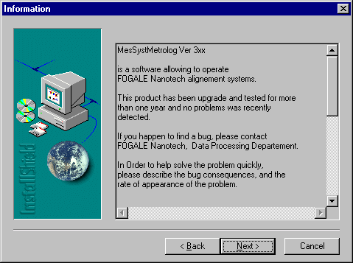

Click on Next to start Setup.

2.2.5. MultiSystMetrolog registration

Before going on with the MSM Setup, the user needs to enter the following information :
- Name: user’s name
- Company: company name
- Serial: serial number to be found at the back of CD jacket.
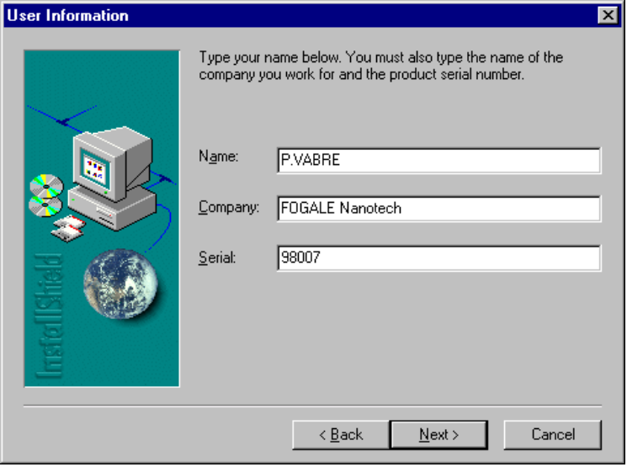

Fill in the three blank spaces and click on Next.

2.2.6. Choosing the folder which contains the Setup files

This dialog allows to valid the folder in which Setup files will be stored. The default folder is Program Files\FOGALE Nanotech (see below). The Browse button allows to select another folder but we strongly advise the user to keep the default selection.
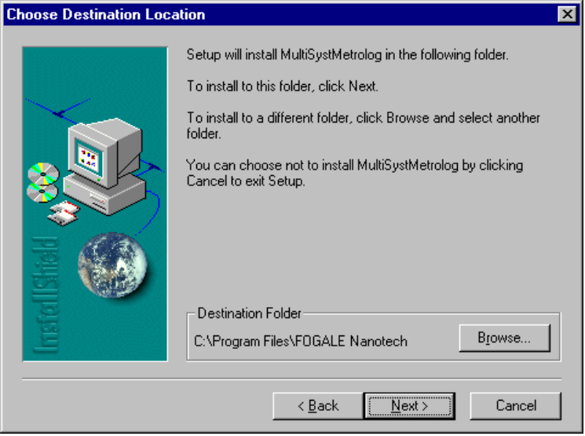

Click on Next to valid the mentioned folder.

2.2.7. Validating the type of Setup

This dialog allows to validate the type of Setup :

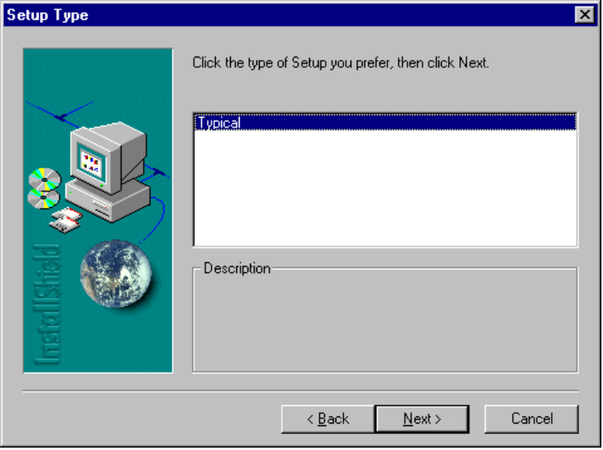
Click on Next to valid the chosen Setup : Typical.

2.2.8. Accessing the software icon

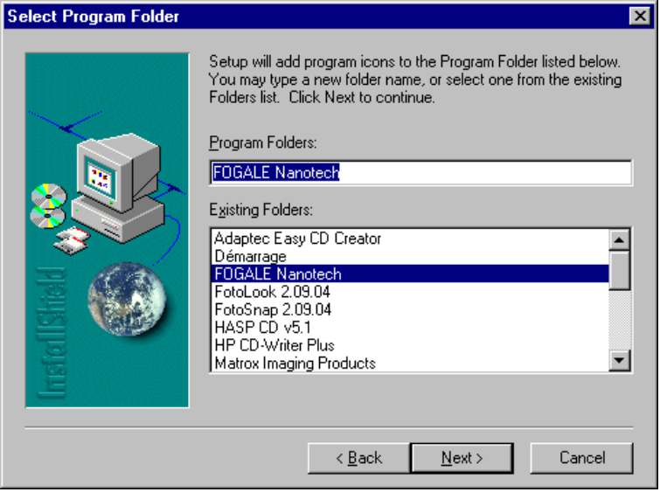The icon of the software running is added in program folders.

Choose the desired folder and click on Next.

2.2.9. Completing the Setup

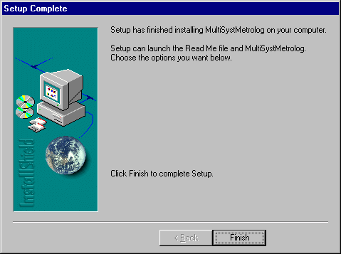The dialog below confirms the success of the software Setup.

Click on Finish to complete the Setup.

2.3. Uninstallation

Use the uninstallation program of MSM to remove all the files associated to MSM.

    - Confirming the uninstallation

The dialog below asks the user to confirm the uninstallation of MSM and all its components.
The Non button allows to cancel the uninstallation.
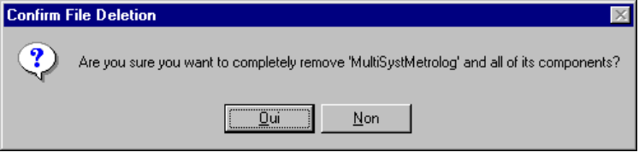

Click on Yes to confirm the uninstallation.

    - Completing the uninstallation

This dialog confirms that the program and all its components have been removed.
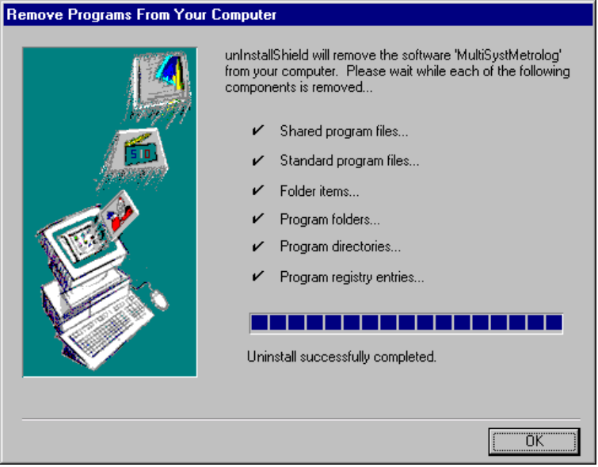

Click on ok to complete uninstallation.

Empty the NT Trash.

2.4. Installation of the electronic key driver

Install the electronic key on the parallel port (printer port).

Launch the hdd32.exe program located on the enclosed CDROM.

The installation menu is displayed. This installation is automatic and your ansver is yes for all the question. Then, restart the machine so that it takes the new driver and the different modifications of the registration keys into account.
The software Setup is completed and you can launch it by clicking on MultiSystMetrolog located in the FOGALE Nanotech sub-folder of the Program Files folder.

If one of the following messages appears “driver is not correctly installed” and/or “key is not detected ”, please contact M. VABRE, Computer Department, FOGALE Nanotech.

2.5 Optimization of the MSM operation in Win NT 4.0

This particular configuration allows, by giving the maximum running priority to our program, to get regular acquisitions and records. The user has to open task manager. Select Processes. Activate the MultiSystMetrolog program and, by clicking on the right button of the mouse, select the set priorities menu and choose the Real time sub-menu. A dialog box warns the user about a possible risk of system dysfunction due to this modification : valid if the system administrator gives the authorization.

2.6 Specific configuration :

In the case the number of instruments is superior to the number of channels of the acquisition system (unsufficient racks number), we can make particular configurations allowing to take one instrumentation or another into account. They are activated by a .bat file that allows to make files copies and launch MSM.

These .bat files are located in the directory c:\program files\fogale nanotech.

Example of file name : copie_config11.bat
copie_config12.bat
copie_config13.bat

